**The Lost Stone**

Mystery | History | Preservation

In a broken village, a lone adventurer runs an errand for an old wise man. What this adventurer unlocks is the tale of the village's history and how it came to be in such a sorry state. But not everyone is open to the wise man's tale, nor his explanation on how the village's conflict centers around the lapis lazuli that was once abundant in the area. It's up to the young adventurer to help the old man put together his story and to decide whether or not his story will be remembered.

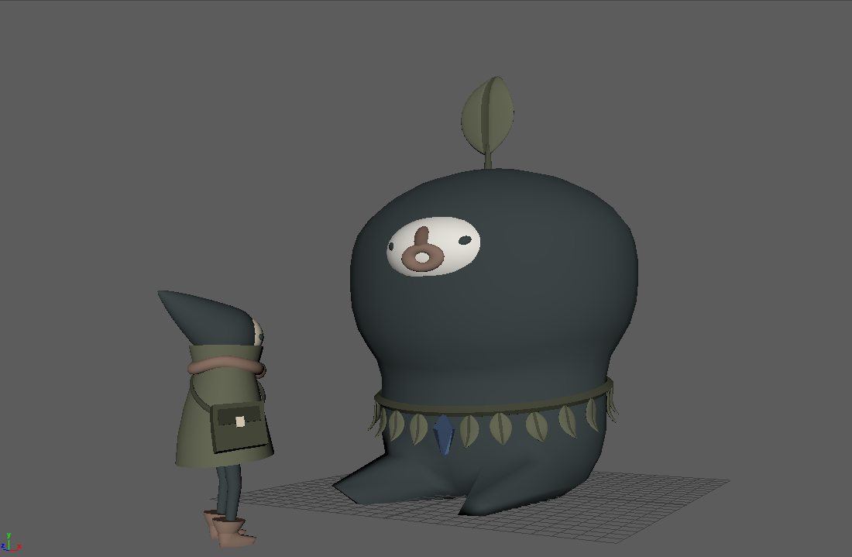

TEAM

Coder - Filipe

Narrative Design - Ashe, Lote

3D Modelers - Rowan, Madi, Lote, Ashe

Sound Design - Madi, Lote

**Themes**

After the player character hears the Old Man's full story, of how the Queen who resides in the castle far away has taken control of the land and its resources, the player is given a choice. The three options the player is given coincide with the main ideas of the game's narrative:

* Learning from history vs. Being willingly ignorant of it
* Correcting the past vs. Erasing it
* Normalizing false narratives vs. Holding people accountable

Though she does not make an appearance, the Queen who rules the setting does so by force. She and her guards are the reason behind the broken buildings in the village, pressuring the remaining inhabitants to ignore the Old Man and to reject his objections. The player, someone who is from a younger generation than the Old Man, holds the key to whether or not the lesson the Old Man teaches will be heard.

**Sound Design**

Using a mix of composed music and field recordings, the audio is designed to immerse participants in a curious world. The composed music is based off of folk music from around the world played on orchestral instruments for an ethereal fantasy experience. In-game sound effects are a combination of orchestral sounds and foley or field recordings. Characters are all voiced by Madi, Lote, and Alex Cleary.

Examples:

<https://drive.google.com/drive/folders/1UahMDaw1HG1W6x8LBpGvKWrRnoeY50cl>

**Concept Art & Development**

